M5032 Financial Markets and Derivatives - Quiz 1 - February 2026
Total Time: 90 minutes; Total Marks :50
Section B (4*5=20 Marks; Maximum Time 45 minutes)
Answer Key

Question 1

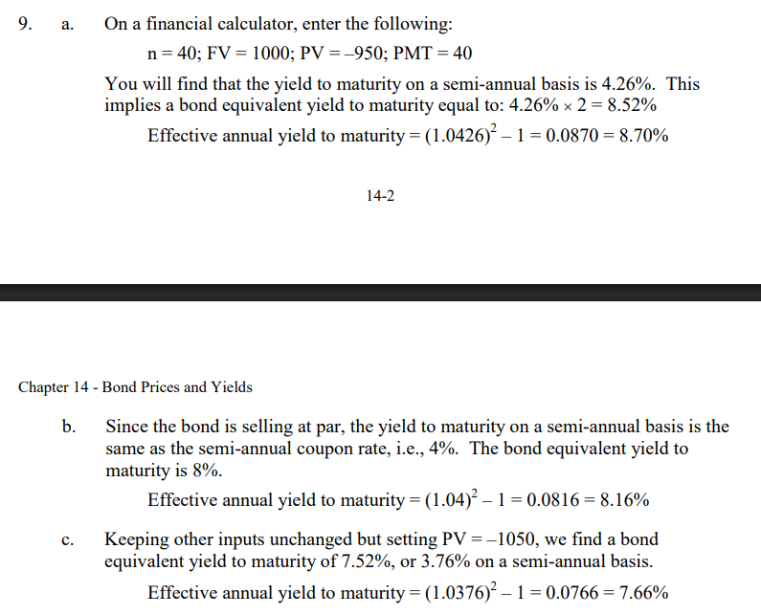

Question 2
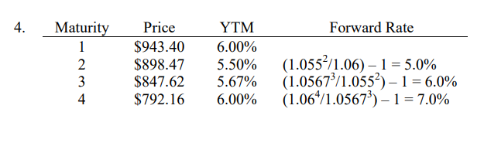

Question 3
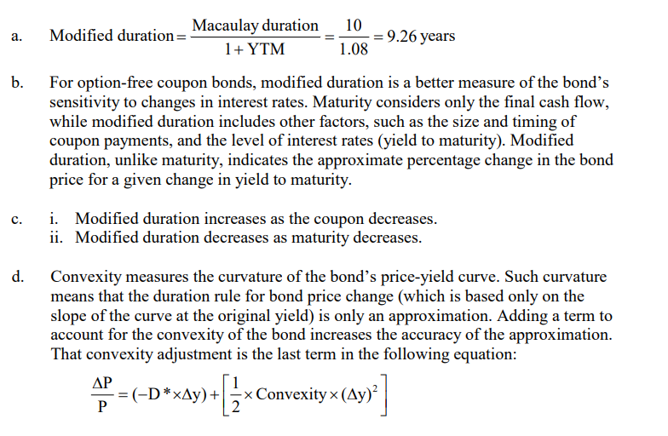

Question 4
